SRTS Policies/Elements to be considered for inclusion in School/District Wellness Plans

For the preamble:
- Whereas, the number of children walking and bicycling to school has significantly declined in the last generation, leading to increased traffic congestion and pollution and putting the health & safety of our children and our environment at risk.
- Whereas the dangers children face on their trip to/from school each day can be mitigated by educating children and parents about safe walking, bicycling, and driver-awareness practices.

General policies regarding providing a school environment that will promote and protect students’ health, well-being and ability to learn:
- All students in grades K-8 will be provided with opportunities, support, education, and encouragement on how to safely walk and/or bicycle to school.
- Schools will provide nutrition education and physical education to foster lifelong habits of health eating and physical activity, including safe pedestrian and bicycling habits, and will establish linkages between health education, environmental education, and school meal programs, and with related community services.

For Integrating Physical Activity into the classroom setting:
- Teachers shall be provided with resources to integrate safe pedestrian & bicycling education into the curriculum, as well as the benefits of walking, bicycling and alternative transportation to health & the environment, at all grade levels.
- Through the curriculum and activities provided through the Safe Routes to School Program--Walk and Roll to school day, bike rodeo, pedestrian and bike safety assemblies/lessons, Walking School Bus—students will learn about and be encouraged to participate in regular exercise that is healthful and ecologically sound.

For Physical Activity Opportunities and Physical Education:
- Classroom physical education and/or health education will provide students with knowledge of safe walking & bicycling practices and an understanding of the benefits of walking & bicycling to their health & the health of the environment, in order to establish and encourage life-long healthy transportation behavior.

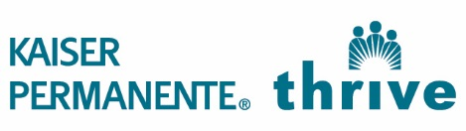
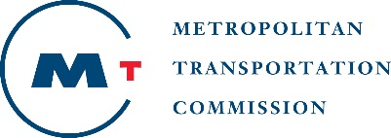
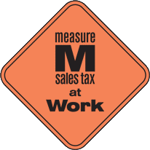

This project is supported by the Metropolitan Transportation Commission’s One Bay Area Grant Program, Measure M, and Kaiser Permanente Northern California Community Benefit Program.

