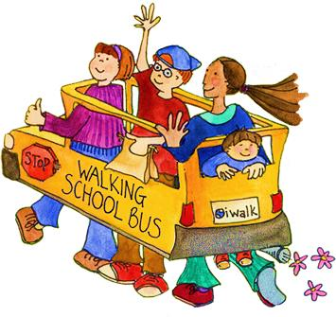

*If you live close-by, walk or bike to one of the meeting points. If you live far away, park near a meeting point and walk part of the way to school. If you live along one of the routes, meet up with the walking bus as it walks by!*

**STARTING WEDNESDAY (Month/Day) !**

**MEET-UP #1: Corner of Cloverdale Blvd & Healdsburg Ave —1 mile (approx. 20 minute walk)**

*Meet on the Southwest Corner. Let’s get ourselves and our kids moving for exercise and fun. Kids who exercise in the morning are more ready to learn and perform better in school!*

**Meeting time:** 7:15am

**MEET-UP #2: Plaza at East 2nd & Cloverdale Blvd - .55 mile (approx. 10 minute walk)**

*Meet at the Plaza, cross Cloverdale Blvd in a big, safe group and walk to school together!*

**Meeting Time:** 7:30am

**MEET-UP #3: Corner of Champlain Ave & Cloverdale Blvd (Goodwill) — .2 mile (approx. 3 minute walk)**

*Avoid the traffic in front of the school, park near Goodwill and walk with your child for two blocks!*

**Meeting time:** 5-15 minutes prior to school start—any day of the week!

**Questions?** Contact (insert name) at (xxx-xxx-xxxx) or email

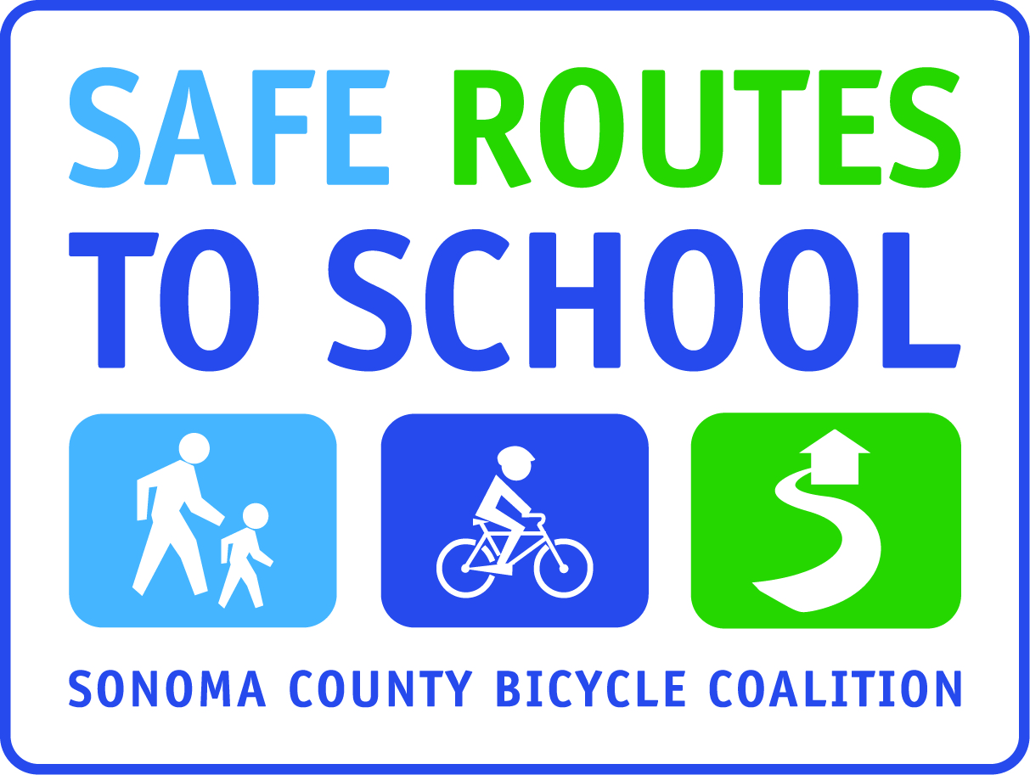

**Walking School Buses, led by parent and/or community volunteers, leave our meet-up points at the times listed below on Wednesday mornings (and other days if desired), light rain or shine. Let’s be a walking school! Please join—for good health, to improve safety in the neighborhood, and to get to know your community!**

**WALKING SCHOOL BUS ROUTES—2013-14**

**(School) ELEMENTARY**