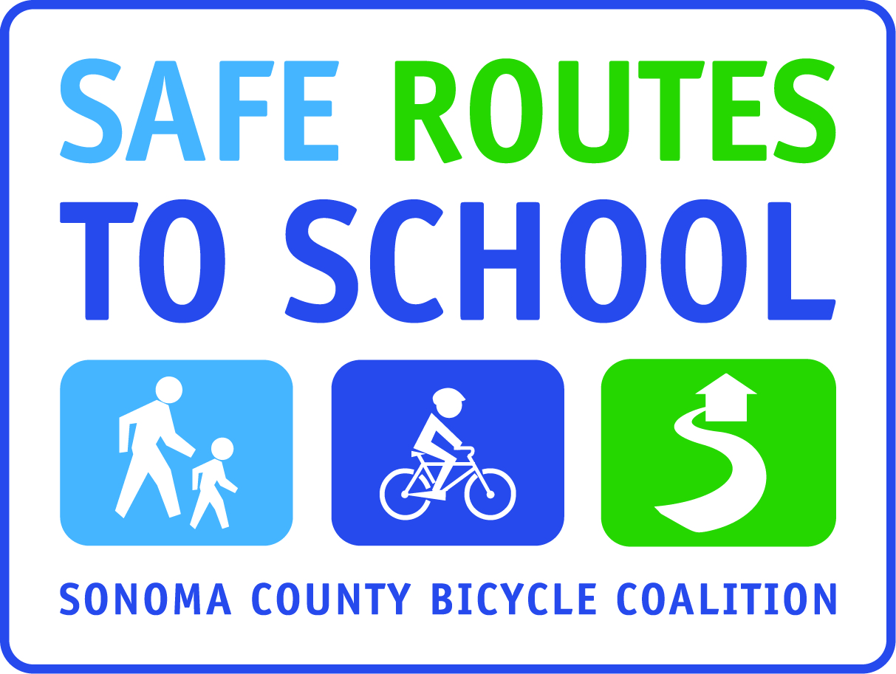
Dear Parent or Guardian,
Today, your child received a Frequent Walk/Roll card from his or her teacher. The Frequent Walk/Roll program begins (fill in date) and continues until (fill in date). During this time period, students will be recognized for walking and bicycling to school, either from home or from any other meeting point(s).
Participating students will (insert appropriate incentive, such as “have a chance to win fun prizes”)
If you follow these simple steps, you and your child will be able to enjoy the fresh air and the health benefits of walking or bicycling, and you will help alleviate the traffic near the school that is causing problems for our school community, the environment, and the health and safety of our children.
- Every day that s/he can, during the contest, encourage your child to walk or bicycle to school, either from home or from another designated meeting point.
- Each day your child walks or bikes to OR from school, mark one of the stars on your child’s Frequent Walk/Roll card.
- Initial only ONE star per day, even if a child walks/bikes BOTH to AND from school that day.
- When your child has walked or bicycled to (or from) school on 10 days, all the stars should be marked, and your child should turn his/her card into his/her teacher/office. He/she will then receive a new card.
- All completed cards are a ticket for (insert appropriate incentive such as end of year raffle, a special item, etc).

Below is an image of the card your child received today. If you child did not bring one home, please request one from his/her teacher or from the school office.

Thank-you for your cooperation!
The (fill in school name) School Safe Routes to School Team

