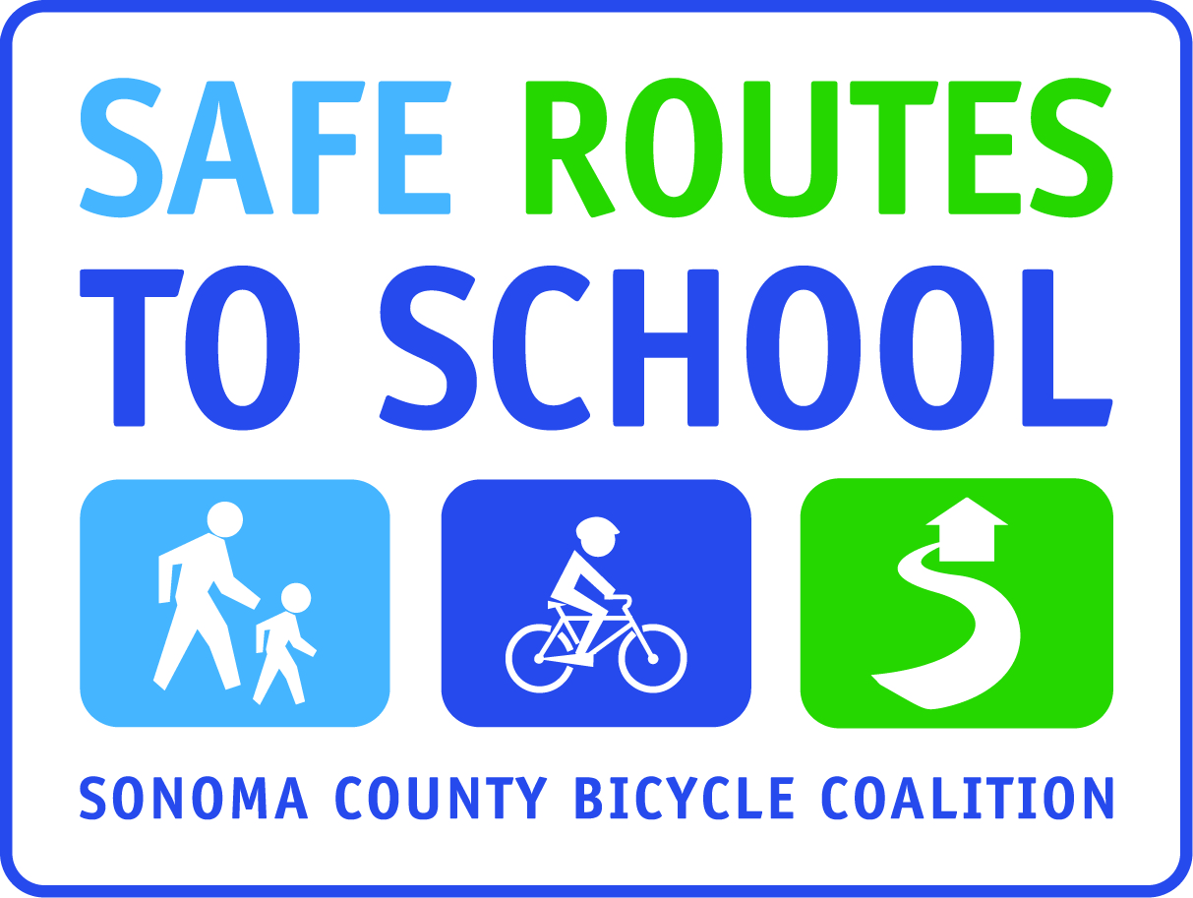

Golden Sneaker Award Tally Sheet

Please turn in your count to_________________by the end of the school day so we are able to calculate the winning classroom!

Teacher:
Grade:
Number of students present today:_____
Total number of students who walked or biked to school today:____

Thank you for supporting Walking and Rolling to School!
______________________________________

Golden Sneaker Award Tally Sheet

Please turn in your count to_________________by the end of the school day so we are able to calculate the winning classroom!

Teacher:
Grade:
Number of students present today:_____
Total number of students who walked or biked to school today:____

Thank you for supporting Walking and Rolling to School!

