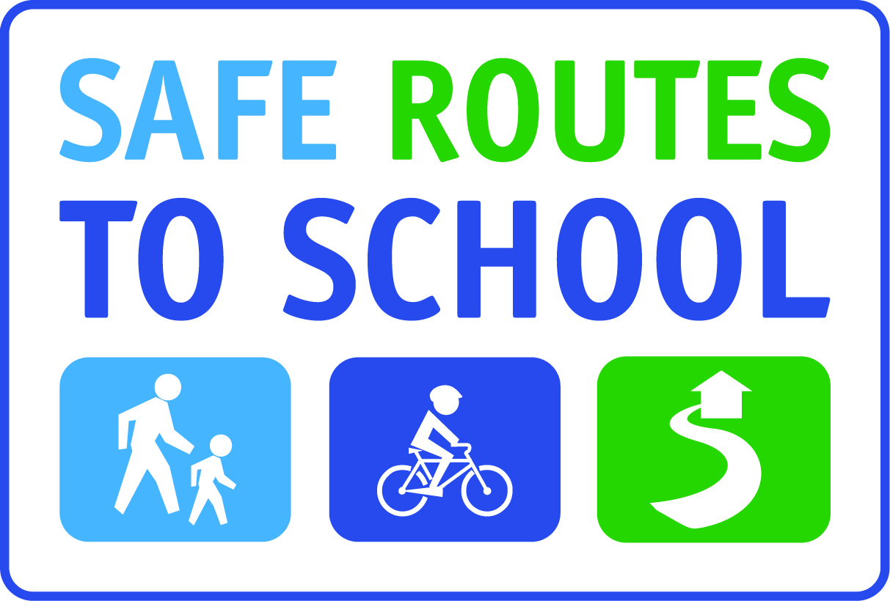

Manager’s Name
Name of Business
Street Address
Town, CA zip

Date

Dear _______(Manager’s Name or Donation Coordinator)__________________:

(Name of school) will be hosting International Walk and Roll to School Day on Wednesday, October 5th. All over Sonoma County, the USA, and the world, schools celebrate and reward students for using human power to get to school. We are seeking donations from the community for our Walk and Roll to School Day event. A contribution from ___(Insert name of business here)______would make a great difference in ensuring our celebration of health, physical activity, and community is a success. We are seeking __(insert number and description of donations or prizes).____ However, we appreciate any donation you can make!

The Sonoma County Safe Routes to School program supports communities in building and using safer routes to school by integrating health, fitness, traffic relief, environmental awareness and safety under one program. I appreciate your support in improving the health and safety of families in our community!

Your donation is tax deductible. The tax ID number of the Sonoma County Safe Routes to School host organization, the Sonoma County Bicycle Coalition, is 68-0467440.

Thank you in advance for contributing to our Walk and Roll program. I will contact you (insert time frame) to answer any questions you have about this request. You may also contact me at _______(insert your phone number or insert your e-mail address)______ ____________.

Sincerely,

(insert your name)

