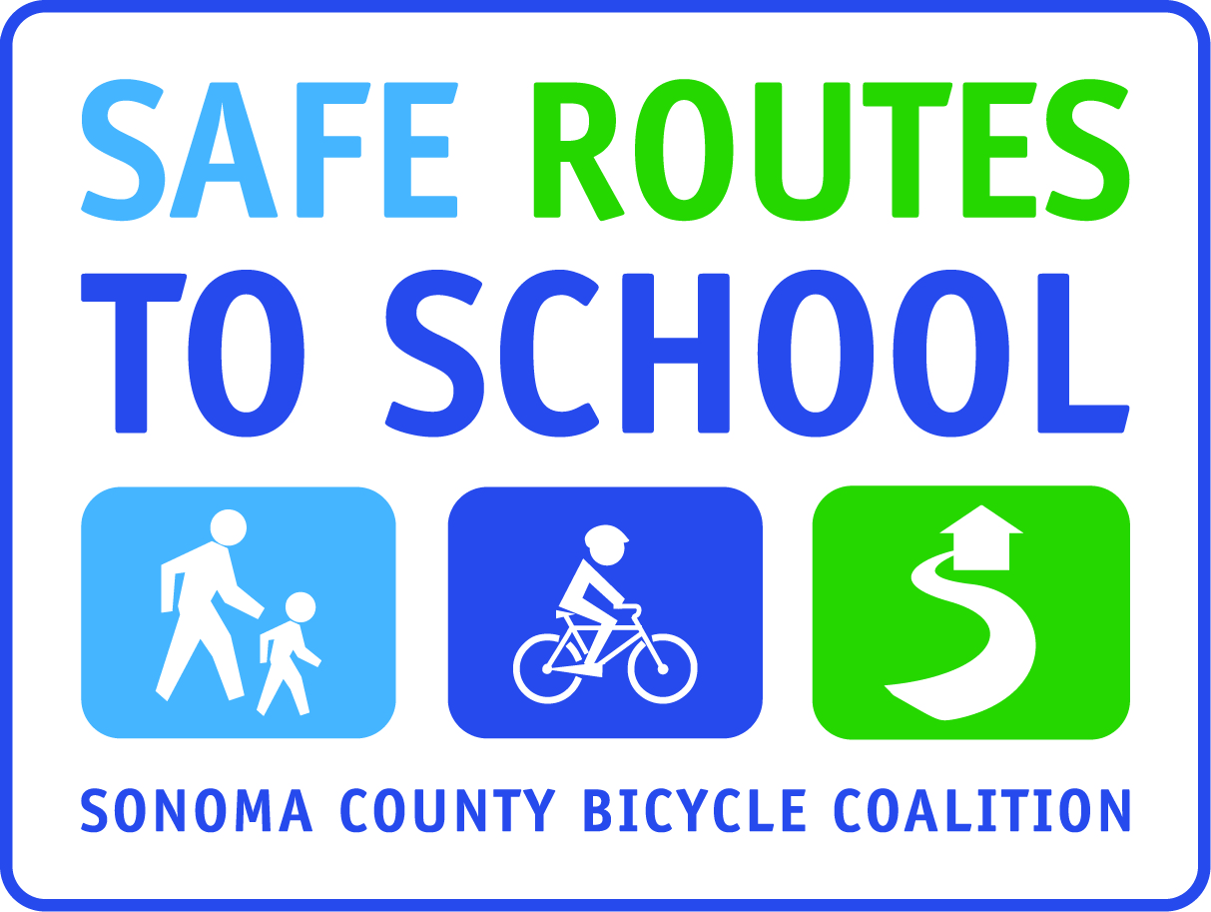
Year-Round Walk/Bike Themes and Safety Tips
For school newsletter articles

End of August or September: Start the School Year Right
As the new school year begins and the leaves start turning, you can turn over a new leaf yourself by trying an active way to school. If you live within a ¼ mile to 1 mile of school, why not start walking or biking at least one day a week? It’s fun and you can meet your neighbors and make new friends. Plus it’s a great way to start the day with a little exercise and fresh air. When your children arrive at school, they are awake and alert, ready to start the school day. Studies have shown a significant relationship between fitness and academic achievement. If you live too far from school to walk the whole way, find a spot that is a 5-10 minute walk, and park and walk to school.

Safety Corner: Parking lots have a lot of traffic coming from multiple directions. Walk, don’t run. Stay close to an adult or older child. Be on the lookout for tail lights. If you see a car backing up, FREEZE, and make eye contact before passing behind it.

Health Corner: A study recently released by the California Department of Education (CDE) shows a distinct relationship between academic achievement and the physical fitness of California’s public school students.

"This statewide study provides compelling evidence that the physical well-being of students has a direct impact on their ability to achieve academically," said Diane Eastin, State Superintendent of Schools. "We now have the proof we’ve been looking for: students achieve best when they are physically fit."

End of September or October: International Walk and Roll to School Day
October 8th is International Walk and Roll to School Day. For more than a decade, children around the world have used this opportunity to leave the car at home and walk or bike to school. Many countries around the world will be celebrating with special events and walking parades. The goal of the walk varies from community to community. Some walks rally for safer and improved streets, some to promote healthier habits and some to conserve the environment. Whatever the reason, International Walk and Roll to School events encourage a more walkable world — one community at a time. This year, (your school) will hold a special event on (date) to celebrate this event. (list any activities that you are doing).

Walking or biking is a great way to start the day, allowing your child to arrive at school refreshed and awake. Use this opportunity to walk and talk together. If you are not behind the wheel of a car, you can give your child your full attention. Walk or bike with your child until you know they can be safe on their own.

Safety Corner: Drivers backing out of or entering a driveway do not always have a clear view of the sidewalk. As walkers and cyclists, stop and check for oncoming traffic before entering or crossing a driveway. As drivers, check for kids in intersections, crosswalks and driveways.

Health Corner: The Centers for Disease Control and Prevention, US Department of Health and Human Services, American Academy of Pediatrics, Institute of Medicine, and The First Lady’s Let’s Move Campaign all recommend 1 hour of physical exercise each day for children and that the bulk of it comes through aerobic exercise. They have all recommended walking and bicycling to school as ways for children to be more active.

End of October or November: Gearing up for Winter
As the season grows colder and wetter, you and your children don’t necessarily need to be less active. Unless it is storming out, children can still walk and even bike to school. Make sure your child dresses properly with bright clothing and layers.
Here are a few tips for cold days:
- Wear bright colors.
- Make sure your child has waterproof rain/snow gear.
- Dress in layers; you warm up quickly when walking and riding.
- Wear hats, hoods, or headbands to cover the neck and ears (under the helmet too when biking).
- Carry umbrellas and wear rain/snow boots.
- Wear full-fingered gloves.
- Wear a wind-proof jacket.
- When riding a bike with your child, make sure to ride slower. The roads are slick and you need to brake sooner.

Safety Corner: Whether you walk or bike, wear light and bright colors! They are easier to see and make you more visible to other people using the road. When driving, remember that kids move in unpredictable ways, keep both hands on the wheel.

Health Corner: Watching less than 10 hours of TV weekly and engaging in brisk walking at least half an hour daily reduces the obesity and diabetes risks by 30 percent and 43 percent respectively. Journal of American Medical Association

End of November or December: Get in the Holiday Spirit
There is nothing like a walk outside in on a crisp cold day to get into the holiday spirit. Now is the time to stay active in anticipation of those hefty holiday meals to come. Set up a routine with your child to walk or bike to school at least once a week. Walking one mile to and from school each day is two-thirds of the recommended sixty minutes of physical activity a day. Plus, children who walk to school have higher levels of physical activity throughout the day.

another article idea
Guide for Buying Bikes for Your Kids
Are you thinking about surprising your child with a shiny, new bike this holiday season? Make sure you get the right bike. A proper fitting bike will maximize your child’s control of the bike, as well as their safety when biking. Avoid purchasing a brand new bike that’s a little big so your child can grow into it. An oversized bike can make it difficult for your child to maintain control and ride safely on the roads.

An accurate inseam measurement is what you’ll need to provide to a local bike shop. To measure your child, ask them to stand with their back against a wall, barefoot, with their feet six inches apart on a hard floor. Place a book firmly between their legs to simulate sitting on a bicycle seat. Measure from the top of the book to the floor bottom. Of course, if you are planning to surprise your child with a new bike then you will need to be clever when they ask you why you are doing this. One suggestion is to tell them that you are making sure that their current bike is a proper fit. Another way to get the right size is to measure the wheel size of their current bike (if they have one). Children’s bike sizes are determined by wheel diameter, not frame size.

Safety Corner: When you ride a bicycle, your helmet is your number one piece of safety equipment. Adults should model wearing a helmet for their children. It is the law for those under 18.

Health Corner: Physical activity during childhood helps build and maintain healthy bones, muscles, and joints, control weight, build lean muscle, and reduce fat and is related to higher levels of self-esteem. Centers for Disease Control and Prevention

End of December or January: Resolve to Walk and Bike More
Get the New Year off to a great start and resolve to walk or bike your kids to school more often. If you are already walking or biking once a week, set your goal to double that to twice a week. Don’t let the cold weather deter you. Bundle up and wear bright colors. If you live too far to walk or bike, then form a carpool with one of your neighbors. You could also find a drop off spot a short distance from school that would allow you and your child to walk part way and reduce congestion around the school. In 1969, 48% of all children walked; 88% who lived within a mile of school. Returning to 1969 levels of walking and bicycling to school would save 3.2 billion vehicle miles, 1.5 million tons of carbon dioxide and 89,000 tons of other pollutants—equal to keeping more than 250,000 cars off the road for a year.

Safety Corner: When walking, before you cross the street--stop, look left, right, left and all around, then listen for traffic. When driving, obey all traffic laws, especially the speed limit and caution signs around schools and parks.

Health Corner: Children are particularly vulnerable to the effects of air quality because they breathe 50 percent more air per pound of body weight than adults. In fact, childhood asthma rates are one of the most common pollution-related health problems in America, with more than 7 million children currently living with asthma. Annually, more than 14 million school days in the United States are lost due to childhood asthma. Make a positive difference by choosing not to idle your car engine in school zones, or utilizing alternative transportation whenever possible. Inhalation of vehicle emissions, even for short periods, are harmful to asthmatics. Additionally, idling for only 30 seconds uses up more fuel than restarting the engine. American Academy of Pediatrics and Environmental Protection Agency

End of January or February: Healthy Heart Month
Walk and bike, it’s good for your heart--Give your children’s hearts a Valentine this February by making sure they walk or bicycle on a daily basis. Happy feet make a happy heart. Make sure your child gets the minimum of physical activity required every day. Public health officials agree that children should have 1 hour of physical activity every day. Yet only 7% of all children meet this goal. Research demonstrates that children who walk or bicycle to school have higher daily levels of physical activity and better cardiovascular fitness than do children who do not actively commute to school. Those who walk and bicycle to school may be at a reduced risk for developing chronic diseases in adulthood.

Safety Corner: When driving, drop your child off on the school-side of the road. Your child is safer when they do not have to cross the street. As a walker, make eye contact with drivers before stepping out into a crosswalk or intersection.

Health Corner: Data from studies indicate that children who use active forms of transport to school (like walking and bicycling) accumulate approximately 20 additional minutes of moderate to vigorous physical activity per day on weekdays and burn about 35 more calories per day than youth who are driven to school. That translates to a saved 6300 calories per year or 2 lbs. of weight gain prevention. Preventing Chronic Disease: Public Health Research, Practice, and Policy

End of February or March: Be Safe and Be Seen
Are you concerned for your child’s safety? The first step to creating a safe community can start with you. Do you follow the rules of the road? Drive slowly and with awareness, especially in school zones. Did you know that 40% of all child pedestrian accidents are from darting out into the street? You never know when a child will appear in front of you, so it’s best to slow down and pay attention. Turn off your cell phone and watch the road. Make sure that your child also knows the rules of the road. When walking, make sure they stop at every edge, whether it’s the curb, a driveway or a parked car. And when biking, make sure they bike the same direction as traffic and always wear a helmet.

Safety Corner: As a driver, look for pedestrians when pulling out of driveways and when driving near vending trucks, buses, parks and schools. Stop and look for pedestrians crossing when making a right hand turn on a red light. As a walker, when crossing the street, it is best to use a crosswalk and/or corner and make eye contact. Crossing between parked cars is not safe.

Health Corner: For every hour people spend in their cars, they are 6% more likely to be obese. For every ½ mile people walk in a day, they are 5% less likely to be obese. If they live in a mixed–use environment, (one in which there are schools, shops, and services near their homes) they are 7% less likely to be obese. Survey done in Atlanta, by Lawrence Frank, Professor at University of British Columbia

End of March or April: Walk and Bike for Earth Day
What better way to walk lightly on Mother Earth than to walk to school every day? With the coming of spring and warmer weather, now is the time to pump up your efforts and try walking or biking to school every day. Short motor trips contribute significant amounts of air pollution because they typically occur while an engine’s pollution control system is cold and ineffective. Schools that are designed so children can walk and bicycle have measurably better air quality. Using fossil fuels leads to the emission of carbon dioxide, a key contributor to global climate changes.

Safety Corner: Driving is not the time for multi-tasking. When driving, use a hands free device to talk on the phone and never text while driving. When walking or bicycling, practice safe behavior and don’t play around with friends or push. Don’t let toys, iPods, or cell phones distract you. Use your eyes and ears at all times.

Health Corner: In America, only 25% of all errands are run by foot, a drop of 42% in the past 20 years. And 75% of all trips are less than a mile from home. Take care of the earth this month, and consider walking or biking to run an errand or to get your children to school before you get in the car.

End of April or May: Bike Commute Month
Enjoy the warm spring air and break out those bikes again. Bike to school as often as you can this month and join millions around the country in experiencing the freedom and joy of bicycle travel. Celebrate bicycling as a fun, healthy way to make your local trips - to work, school, the store, library, or movie. Here are a few fun facts about bicycling:
- Orville and Wilbur Wright, the brothers who built the first flying airplane, operated a small bike repair shop in Dayton, Ohio. They used their workshop to build the 1903 Wright Flyer.
- Fred A. Birchmore, 25, circled the globe by bicycle in 1935. The entire trip, through Europe, Asia, and the United States, covered forty thousand miles. He pedaled about 25,000 miles. The rest was traveled by boat. He wore out seven sets of tires.
- Americans use their bicycles for less than one percent of all urban trips. Europeans bike in cities a lot more often—in Italy 5 percent of all trips are on bicycle, 30 percent in the Netherlands, and seven out of eight Dutch people over age 15 have a bike.
Facts taken from:
Bicycle: The History by David Herlihy
The World Almanac Book of Records: Firsts, Feats, Facts & Phenomena by Mark Young

Safety Corner: Before riding your bike, do an ABC Quick Check:
A: Air pressure; make sure your tires are inflated.
B: Brakes, check to make sure they are working properly.
C: Chain, see that it is oiled and that shoe laces and pant legs are out of the way.

As drivers, communicate with cyclists and pedestrians just like you do with other drivers.

Health Corner: Bicycling burns 500 calories an hour. And if you bike an hour a day, you shed 1 lb. per week. Benefits of bicycling include increased cardiovascular fitness, strength, balance and flexibility, endurance and stamina, and calories burned. 3 hours of biking per week can reduce the risk of heart disease and stroke by 50%! Climate Justice Youth Academy

End of May or June: What I’m doing on my Summer Vacation – Bicycling!
It’s summer time, and the living is easy. Time to crank it up and bicycle more! Why drive your child two blocks away to a friend’s house when he or she can walk or bike. Get the whole family involved and plan out your vacation with bicycling in mind. Bring the bikes along and spend some of your time exploring new places on foot or by pedaling. Take your kids around town on bicycle. Visit the trails near your home. Your kids won’t be bored and neither will you.

Safety Corner: Be Predictable, Stay Alert! Use your eyes and ears when riding. Be on the lookout for glass, potholes and other hazards. Listen for sirens and brakes. Don’t use headphones while riding. As drivers, give cyclists a three-foot wide space when you pass.

Health Corner: Riding a bike and walking are proven stress releasers. They get you relaxed, energized and happier about the world and yourself. We end up spending the majority of our days indoors, it’s now time to switch it up—get outside and get moving—your body will thank you for it!

Funding for this project was provided in part by a grant from the Federal Safe Routes to School in partnership with Sonoma County Departments of Transportation and Public Works and Health Services, and in part by the Measure M Transportation Tax.

