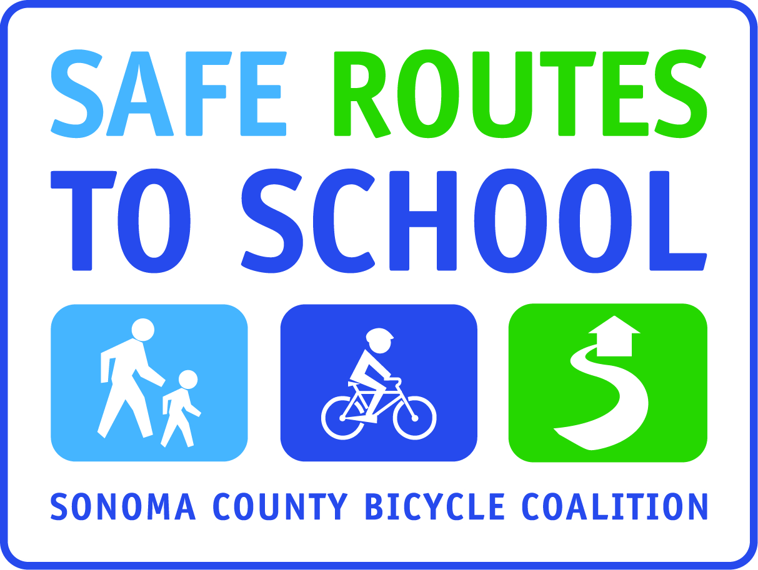
Dear Parent or Guardian,
Today, your child received a Pollution Punch card from his or her teacher. The Pollution Punch Card Contest begins on (fill in date) and continues for (#) weeks, every (fill in day), until (fill in date). The contest hopes to decrease traffic congestion and harmful car emissions in and around the school zone and encourage walking and bicycling as a healthy, fun, and social habit. Students can build responsibility and organizational skills by planning ahead to walk or bicycle every day, which helps to integrate these good habits as a natural part of their daily lives. Plus you and/or your child will be able to enjoy the fresh air and wonderful times of getting to school together and be eligible for some fun awards!
To participate, just have your child follow these simple steps:
- Walk, bicycle, scooter or skateboard to school every (fill in day) between (fill in beginning date) and (fill in end date).
- If you are unable to walk/roll from home, walk or roll with one of the Walking/Bicycling School buses from the (fill in meet-up locations or mention that students/families can park and walk from a location ¼ or ½ mile away).
- Attach your card to your backpack or somewhere where it can’t be lost and will always be with you when you arrive at school on (fill in day) mornings.
- Volunteers will be in front of the school (or mention how/where cards will be punched), ready to punch cards of walkers or rollers who have them ready every (fill in day).

(choose which option(s) you will use for your school – below are examples of possible options)
- Students who participate all six weeks will get to (fill in reward, such as participate in pizza party, play a game, make/receive bicycle-blended smoothies, etc) at a special event in (fill in month, date can be TBA).
- Students who participate (insert #) or more times will be entered into a raffle for (insert prize(s).
- Every child who turns in a card with at least one punch will receive a special Walk & Roll gift.
- Each week during the contest, the classroom with the highest percentage of walkers/rollers will receive the coveted “Golden Sneaker” award, and we will announce how many carbon emissions and pollutants we saved!

Below is an image of the card your child received today. If your child did not receive one, please request one from his/her teacher or from the school office.
Thank-you for your cooperation!

The (School) Safe Routes to School Team

