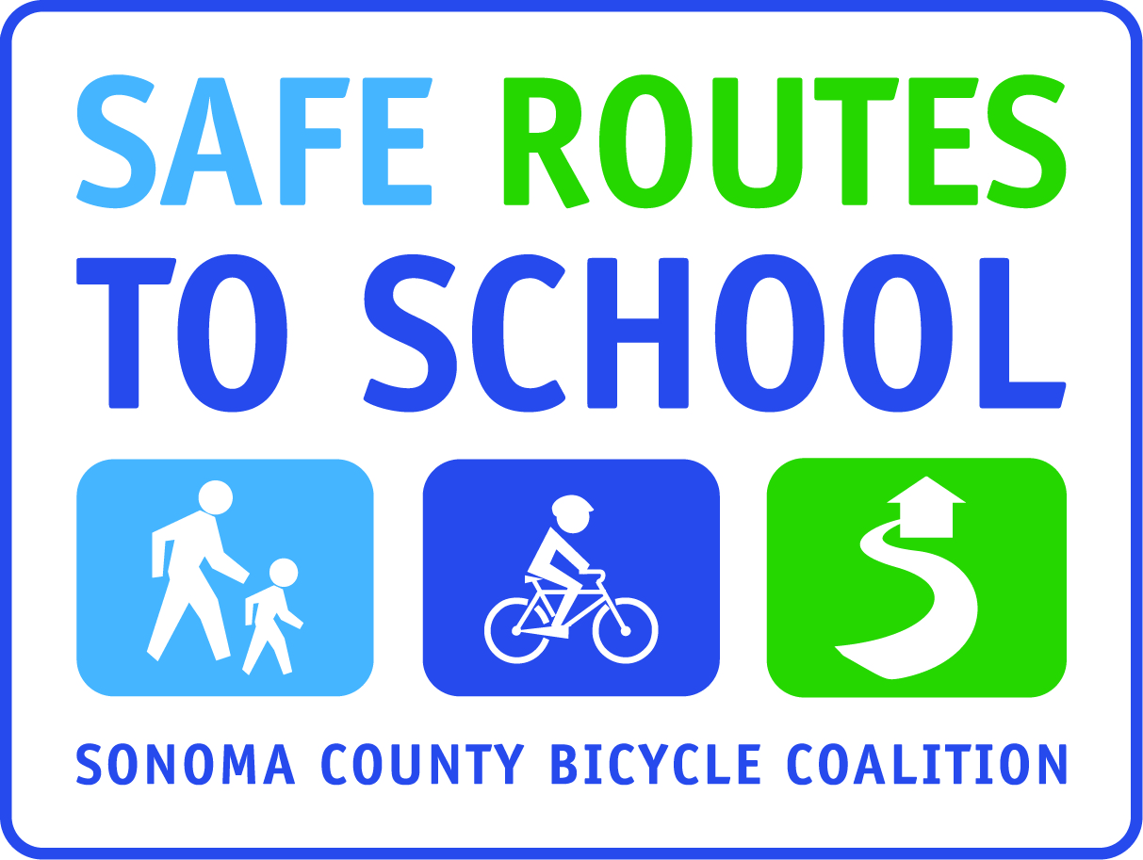

I LOVE WALK AND ROLL TO SCHOOL
ESSAY WRITING CHALLENGE

For Students in (insert grade levels)

Essays must be submitted by (insert day/date)

Essays will be (insert how essays will be shared/published/displayed at your site)

Requirements:

Describe in a 250-350 word essay why you love walking and/or rolling to school.

- Essay may be typed or written in ink (no pencil please).
- Your essay must have a title
- Label entry with first and last name, grade and teacher
- One submission per person

Insert line indicating the type of “credit” students will receive for submitting a poem to the Exhibit Challenge.

Submit Entries to: (insert where entries will be submitted)

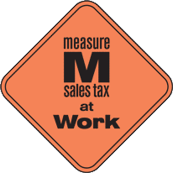
This project is supported by the Metropolitan Transportation Commission’s One Bay Area Grant Program, Measure M, and Kaiser Permanente Northern California Community Benefit Program.

