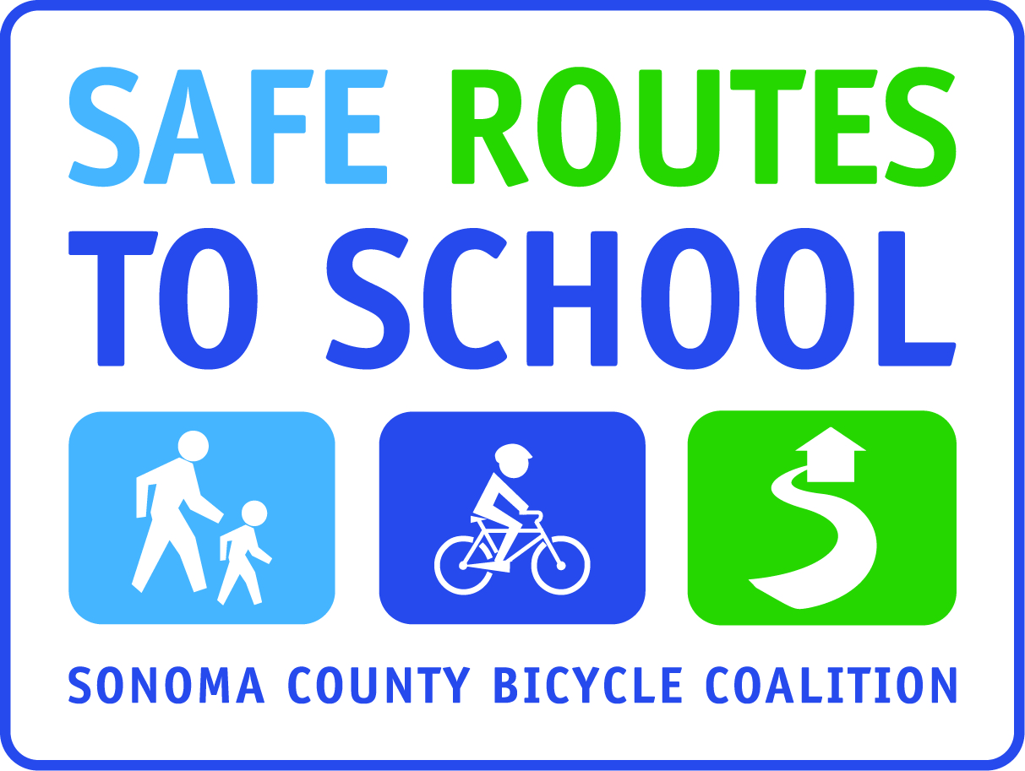

I LOVE WALK AND ROLL TO SCHOOL
POETRY & ILLUSTRATION
EXHIBIT CHALLENGE

For Students in (insert grade levels)

Poems must be submitted by (insert day/date)

POEMS/ILLUSTRATIONS WILL BE PUBLISHED/DISPLAYED/EXHIBITED
(insert how you will share submitted poems)

Requirements:

Describe in a (minimum 10 line) poem and corresponding illustration why you love walking and/or rolling to school.

- Poem may be typed or written in ink (no pencil please).
- Illustration may be in color or black and white, and can anything from simple drawing to highlight an idea in your poem, to a full page illustration
- Your poem must have a title
- Label entry with first and last name, grade and teacher
- One submission per person

Insert line indicating the type of “credit” students will receive for submitting a poem to the Exhibit Challenge.

Submit Entries to: (insert where entries will be submitted)

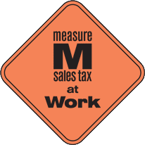
This project is supported by the Metropolitan Transportation Commission’s One Bay Area Grant Program, Measure M, and Kaiser Permanente Northern California Community Benefit Program.

