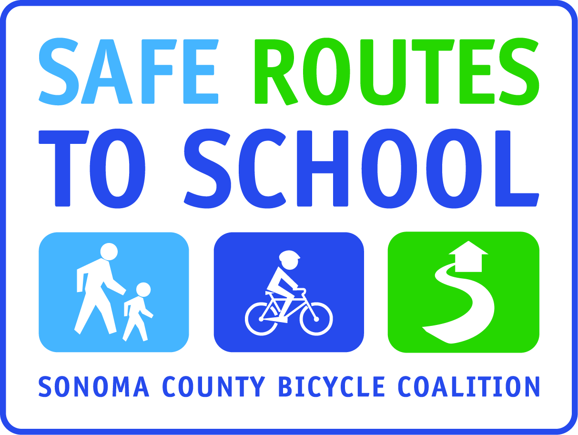

I LOVE WALK AND ROLL TO SCHOOL POETRY CONTEST

For Students in (insert grade levels)

Poems must be submitted by (insert day/date)

Winners Announced in (insert date)
Winners & Runners Up will be published/displayed (insert how you will share)

Requirements:

Describe in a (minimum 10 line) poem why you love walking and/or rolling to school.

- Poem may be typed or written in ink (no pencil please).
- Your poem must have a title
- Label entry with first and last name, grade and teacher
- One submission per person

Poem will be judged for ability to express enthusiasm for walk & roll, and also on creativity and originality.

- 1 Grand Prize Winner (at each grade level?) will receive (insert)
- (insert #) Runners Up will receive (insert)
- (insert #) Honorable Mentions will receive (insert)
- All of the above invited to read their essay at (insert time/location)

Submit Entries to: (insert where entries will be submitted)

Email entries to: (insert)

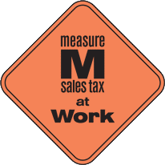
This project is supported by the Metropolitan Transportation Commission’s One Bay Area Grant Program, Measure M, and Kaiser Permanente Northern California Community Benefit Program.

