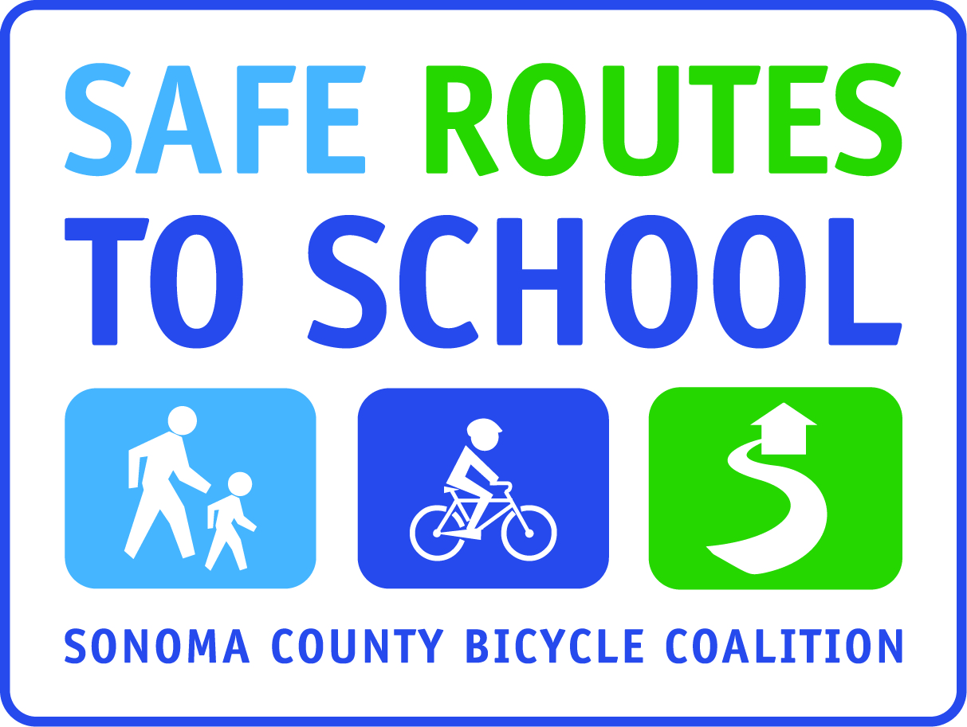
WALK AND ROLL TO SCHOOL SAFETY POSTER CONTEST!
POSTERS MUST BE SUBMITTED by (insert date)
^{winner announced (insert date)}
Design a poster that illustrates how to safely walk or ride your bicycle. Your poster should include a safety slogan and also illustrate one or more of the pedestrian &/or bicycle safety concepts listed below:

- Walk on sidewalk (if no sidewalk, walk facing traffic)
- Stop, look left-right-left & all around, & listen before crossing
- Cross at crosswalks or corners; but make sure ALL cars in ALL lanes have stopped before crossing!
- Dress to be seen (be visible)
- Be predictable – don’t make sudden moves
- Stay alert - don’t let cell phones or ipods distract you
- Ride bikes with traffic, on the right
- Obey traffic laws & signs
- Wear your helmet & make sure it fits correctly
- Use hand signals when turning
- Check air, brakes & chains & make sure shoelaces and pant legs are out of the way before riding

- Posters must be in color
- You must include a slogan at the bottom or top of your picture that captures the safety concepts or rules you are communicating:
- CLEARLY write your first and last name, and grade on the front of your poster

(insert #) winning posters will be selected (insert additional parameters, if any, like # per grade level) and displayed/shared (insert information on how they will be shared)
Winners will receive (insert incentive)

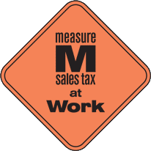
This project is supported by the Metropolitan Transportation Commission’s One Bay Area Grant Program, Measure M, and Kaiser Permanente Northern California Community Benefit Program.

