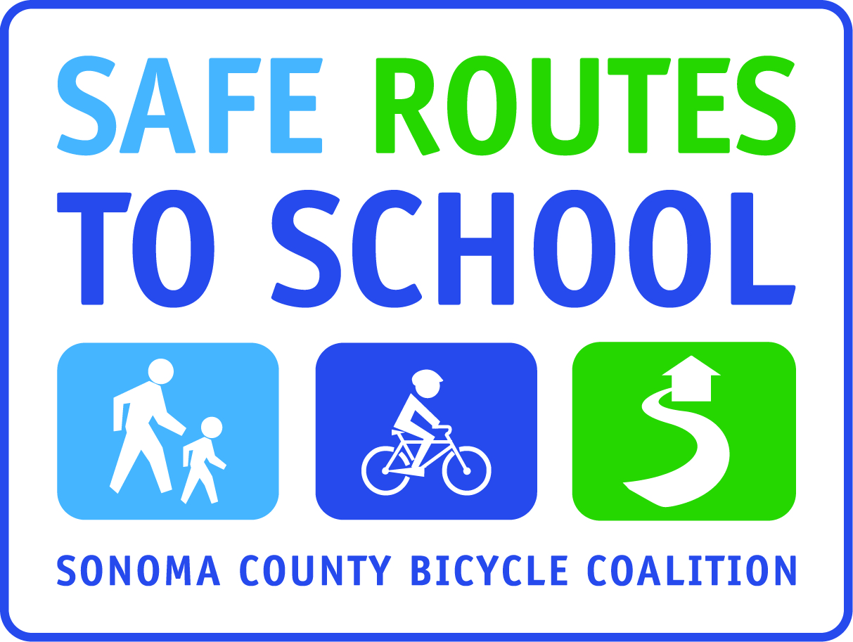

WALK AND ROLL TO SCHOOL POSTER CONTEST!
POSTERS MUST BE SUBMITTED by (insert day/date)
winner announced in (insert date)
Draw a picture and write a caption that illustrates and/or is inspired by one of the four fantastic reasons for Walking or Bicycling to School. The reasons are:
It’s Fun!
It’s Healthy!
Less Pollution (or Carbon Emissions)!
Less Traffic!

- Pictures must be in color, on an 8 ½ x 11 sheet of paper.
- You must include a caption at the bottom or top of your picture that describes the reason you drew about. Examples:
  - Walking and bicycling is fun!
  - Walking and Bicycling is fun because I get to be with my friends!
  - Walking and biking helps the earth because it causes less pollution than cars.
- Write your first and last name and grade level on the front of your picture
- You may submit pictures for more than one reason – but please, only one reason per picture!

Winning posters will be selected from (insert parameters; one per slogan, one per grade level, one per slogan per grade level, etc)

The winning posters will be (indicate what you will do with winning pictures; i.e. post in office, include in school newsletter, made into posters that will be hung around school, etc)

Winners will receive (insert prize if any)

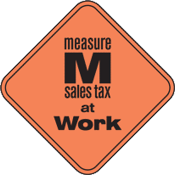
This project is supported by the Metropolitan Transportation Commission’s One Bay Area Grant Program, Measure M, and Kaiser Permanente Northern California Community Benefit Program.

