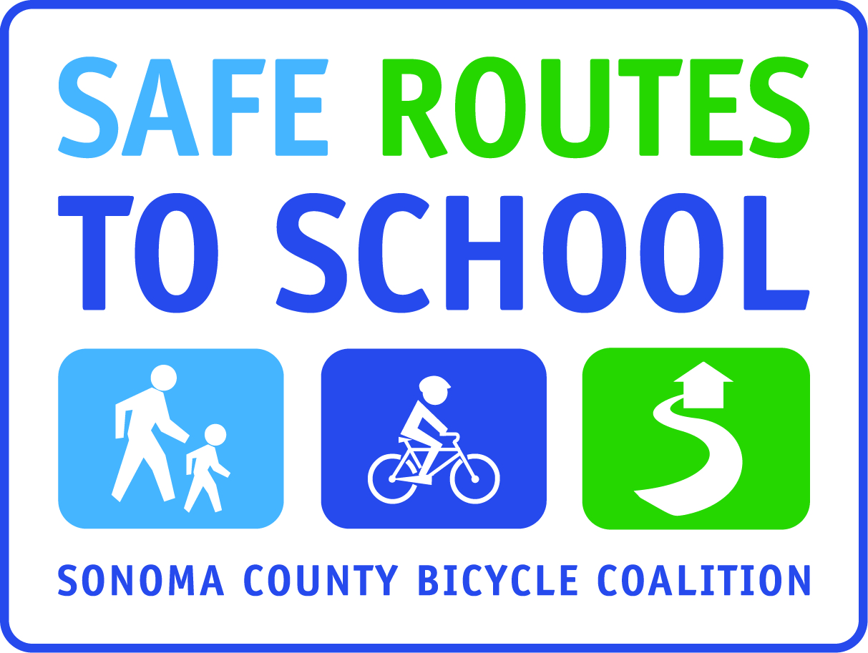

WALK AND ROLL TO SCHOOL
POSTER EXHIBIT!
POSTERS MUST BE SUBMITTED by (insert day/date)

Draw a picture and write a caption that illustrates and/or is inspired by one of the four fantastic reasons for Walking or Bicycling to School. The reasons are:
It’s Fun!
It’s Healthy!
Less Pollution (or Carbon Emissions)!
Less Traffic!

- Pictures must be in color, on an 8 ½ x 11 sheet of paper.
- You must include a caption at the bottom or top of your picture that describes the reason you drew about. Examples:
  - Walking and bicycling is fun!
  - Walking and Bicycling is fun because I get to be with my friends!
  - Walking and biking helps the earth because it causes less pollution than cars.
- Write your first and last name and grade level on the front of your picture
- You may submit pictures for more than one reason – but please, only one reason per picture!

POSTERS WILL BE EXHIBITED IN (insert location) ON (insert date or date range) IN CELEBRATION OF (insert reason, such as a monthly Walk/Roll event or contest)

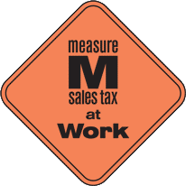
This project is supported by the Metropolitan Transportation Commission’s One Bay Area Grant Program, Measure M, and Kaiser Permanente Northern California Community Benefit Program.

