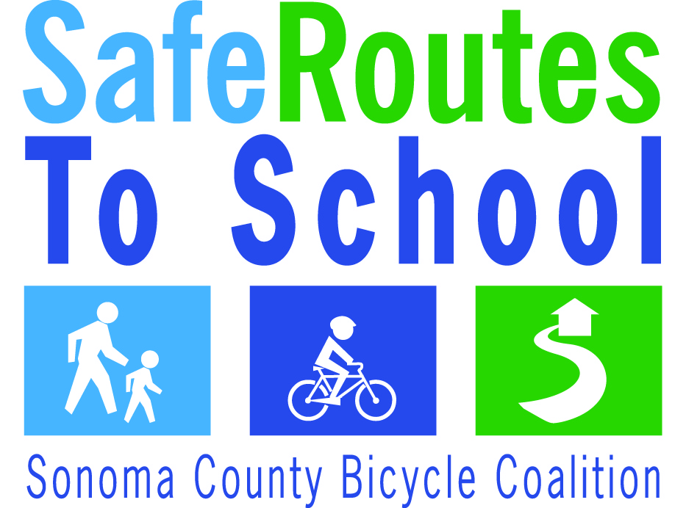
Sonoma County Bicycle Coalition
WALKING/BICYCLING SCHOOL BUS ENROLLMENT FORM
I can walk or bike children to and/or from _______________________school on the following days:

Monday | □ Morning | □ Afternoon
Tuesday | □ Morning | □ Afternoon
Wednesday | □ Morning | □ Afternoon
Thursday | □ Morning | □ Afternoon
Friday | □ Morning | □ Afternoon

From the following location: __________________________________________________________________
Intersection
Starting at: ______________________________________________ Mode (circle one): WALK BIKE
Time
Name: ____________________________________________________________________________________
Print
Address: __________________________________________________________________________________
Street, City, Zip
Telephone: ___________________________________ Email: ______________________________________
Title of My Walking/Bicycling School Bus (i.e. Main Street Walking School Bus)______________________________________________________________________________________
I agree to allow my Walking School Bus information, including my name and phone number, to be distributed in school communications, so parents who are interested in having their children join my walking/bicycling school bus may contact me. I am not obligated to allow children to join my walking school bus without their parent present, unless I am comfortable supervising those children and have exchanged contact information with the parent. I will ensure that there is adequate supervision of children who participate on my walking/bicycling school bus, during the time they are walking or biking to/from school with me (suggested: 8 or less children per adult, or whatever I am comfortable with).

Signature: ___________________________________________Date:_________________________________

Funding for this project was provided by MTC’s Congestion Mitigation and Air Quality (CMAQ) Program in partnership with Sonoma County Departments of Transportation, Public Works and Health Services, and the Sonoma County Bicycle Coalition.

