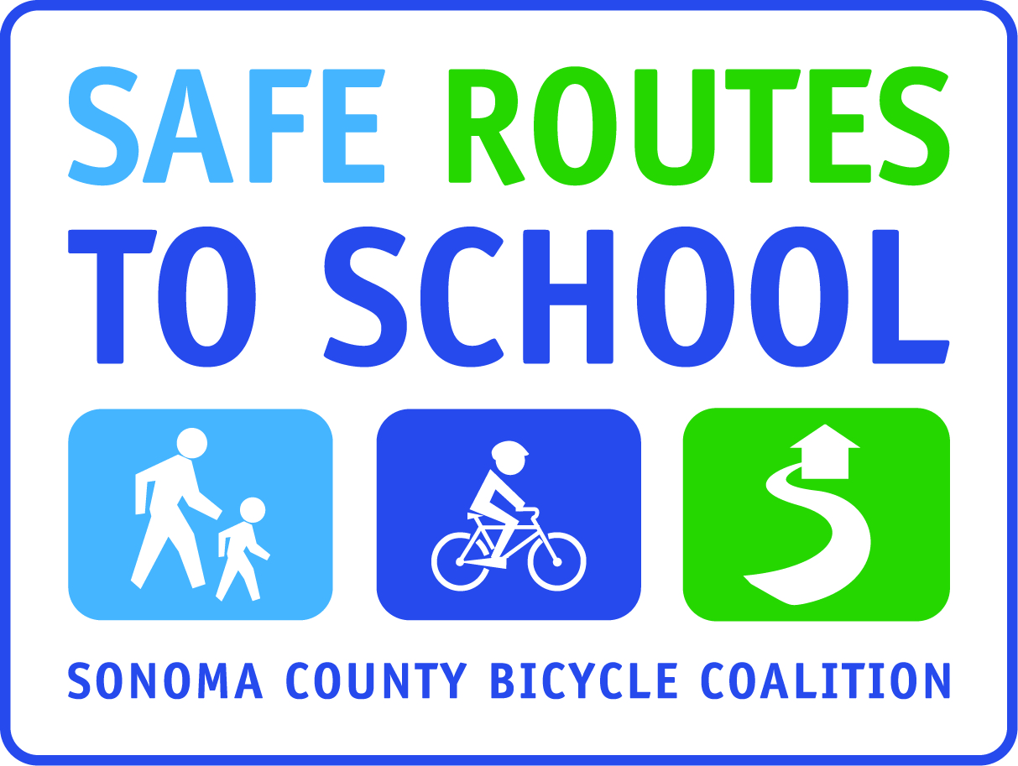
(School Name)
Walk & Roll Wednesdays

We would LOVE to support more families walking or bicycling to school together —it strengthens our community, it gets our students active and ready to learn, and it’s good for the environment.

We are looking for moms, dads, grandmas and grandpas to help us start “Walking School Buses” on Wednesday mornings. You do not need to live close to our school to participate. We have established the following potential meet-up points: (add locations). We need adults who would be willing to walk from those locations to school, joining with students along the way. If interested, please return the bottom portion of this form and we will contact you.

Let’s work together to promote a safe and healthy way to get to school! If you have any questions, you may contact (Principal or team leader) at (phone number) or (email).

****************************************************************************

❒ I am willing to walk with students on Walk/Roll Wednesdays.
(The more adult presence we have on the streets, the safer our community will be)

___________________________ _________________________ ______________________________
Parent Name phone number email

_____________________________________________________________________________________
Home address

Preferred Meet Up Point (check one or more):

_____ add location and time
_____ add location and time
_____ add location and time
_____ Other_________________________________________________________________________

By returning this form, you are not committing to walking every single Wednesday, you are simply indicating this is something you would be willing to do – we hope to have enough interested parents to establish a safe and fun way for kids and parents to walk to school together every Wednesday from these locations!

